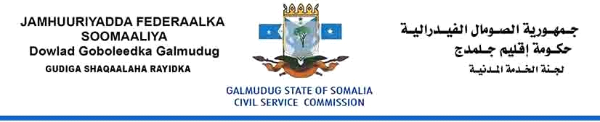

Vacancy Announcement
Director General
State House
Grade: 8
Reporting to: Galmudug President
Salary: $1200
Location: Adaado-Somalia
Date of issued: 30 October, 2017
Closing date: 20 November, 2017

The Civil Service Commission is established to oversee the proper functioning of the Civil Service of the Galmudug State and to ensure that the Civil Service is efficient and effective in serving the community, affordable within state budget resources, and based on merit and equality of opportunity.

The Director General is the Managerial and Administrative Head and of the Statehouse, responsible for directing and coordinating the activities of the Statehouse. She/he performs the policy setting role while the Functional Heads of the Statehouse are responsible for executing the technical aspects of the Statehouse’s functions.

Purpose

The Director-General is required to build a culture of professionalism, respect and integrity to ensure a positive working environment, acknowledging the responsibilities of Statehouse and supporting managers to make evidence-based decisions. The Director-General is responsible for ensuring that management decisions are free from nepotism, patronage and that are seen to be based on merit. Acting truthfully, fairly and in the public interest in addition to creating and maintaining stakeholder confidence through leadership which fosters and promotes ethical, decision making is a key element of this position.

Duties and Responsibilities
The Director General duties include but are not limited to the following responsibilities:

- Provide overall State leadership and direction (conceptual and operational) on all matters of State importance so that the State ideals, principles and objectives are upheld, enhanced and realised.
- Effectively coordinate, monitor and evaluate, at overall State level, the inter-related ministerial policies and operations to ensure optimal utilisation of all resources and effective attainment of State objectives and goals.
- Develop and maintain sound policies and relations between the Somali Federal Member States and between Galmudug State Ministries to which will foster State and national progress and interstate peace and stability.
- Support the provision of overall leadership in public policy management and promotion of good governance in public institutions.
- Provide efficient and effective support to Cabinet in discharge of its constitutional mandate of formulating and implementing government policies.
- Cultivate and promote a favourable positive image of the Galmudug State of Somalia for enhancement of trade, investment and State culture.
- Ensure that Government policies programs and projects are adequately communicated, monitored and evaluated.
- Mobilize the population towards achieving social and economic development to promote programs which enhance the prosperity of the people of Somalia.
- Promote good governance in public institutions and civil society.
- Ensure all official correspondence relating to the office of the President is documented and filed in accordance with policies and procedures.
- Ensure that minutes of all official meetings including cabinet meetings are documented and filed in accordance with policies and procedures.
- Oversee travel arrangements including the logistics, welfare and security of the President and vice President.
Qualifications and Experience

- Bachelor Degree in International Studies, Business Administration, Public Administration, Economics, or relevant academic field. Having Master Degree in above fields is desirable.
- This position requires at least 5 years’ experience obtained by managing Statehouse, a public/private-sector organizations, Ministry, or institution at a senior level.
- Work in directorate position is desirable.

Knowledge

The Director General is expected to possess an exceptional knowledge of:
- Modern personnel management practices.
- Principles of sound public administration.
- Sound knowledge Statehouse management, such as Office of the President and the affairs of the State.
Competences
The Director General must demonstrate
- Public Administration skills.
- High standards of ethical behaviour and integrity.
- Demonstrated outstanding leadership and organisational development skills.
- Ability to identify, analyse and solve complex problems.
- Ability to plan and organize work to ensure effective implementation of Ministry functions.
- Possesses high level political, analytical, policy and management skills.
- The ability to provide leadership, direction and motivation to staff.
- Excellent interpersonal and facilitation skills, including the ability to effectively work with and support the members of a team and work collectively in partnership with a wide range of stakeholders.
- High standards of ethical behavior and integrity.
- Excellent written and verbal communication in English and Somali language.

How to apply:
Please download Application Form:

Interested candidates who meet the criteria are encouraged to fill the form and send to recruitment.cscgmstate.so@gmail.com, and please make sure to copy or Cc, the following email: csc.galmudug@gmail.com. CVs and Application Letter will not be considered, kindly indicate the position title and Ministry on the subject line when you applying. Female Candidates are strongly encouraged.

The selection process will begin as soon as possible after the closing date. Selected candidates will be invited to written Exam and an interview.

