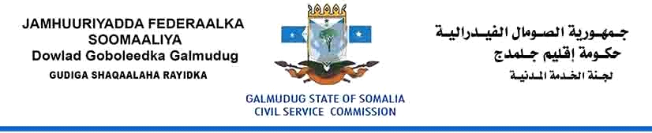

Vacancy Announcement
Director General
Galmudug Parliament
Grade: 8
Reporting to: The Speaker of the Parliament.
Salary: $1200
Location: Adaado-Somalia
Date of issued: 30 October, 2017
Closing date: 20 November, 2017

The Civil Service Commission is established to oversee the proper functioning of the Civil Service of the Galmudug State and to ensure that the Civil Service is efficient and effective in serving the community, affordable within state budget resources, and based on merit and equality of opportunity.

The Civil Service Commission is currently recruiting to fill the position of Director General to direct and coordinate the activities of the Parliament and set policy. This is a great opportunity for the right person to progress their career with the Civil Service and provide leadership in establishing this important Parliament for the benefit of the people of Galmudug State of Somalia (GSS).The Director General will support the Parliament in developing policies to promote legislation issues, ensuring public safety and strengthening Government capability aimed towards the effective delivery of basic services to the people of GSS.

The Director General is the Managerial and Administrative Head and of the Parliament, responsible for directing and coordinating the activities of the Parliament. She/he performs the policy setting role while the Functional Heads of the Parliament are responsible for ensuring Parliament's agenda is well facilitated and provide all the technical support required by all Parliamentary committees.

The Director-General is required to build a culture of professionalism, respect and integrity to ensure a positive working environment, acknowledging the responsibilities of Parliament and supporting managers to make evidence-based decisions. The Director-General is responsible for ensuring that management decisions are free from nepotism, patronage and that are seen to be based on merit. Acting truthfully, fairly and in the public interest in addition to creating and maintaining stakeholder confidence through leadership which fosters and promotes ethical decision making is a key element of this position.

Duties and Responsibilities

The Director General duties include but are not limited to the following responsibilities:

- Provide overall State leadership and direction (conceptual and operational) on all matters of Parliamentary importance so that the ideals, principles and objectives are upheld, enhanced and realised.
- Effectively coordinate, monitor and evaluate, at overall Parliamentary level, the inter-related ministerial policies and operations to ensure optimal utilisation of all resources and effective attainment of objectives and goals.
- Support the provision of overall leadership in public policy management and promotion of good governance in public institutions.
- Provide efficient and effective support to Parliament in discharge of its constitutional mandate of formulating and implementing government policies.
- Cultivate and promote a favourable positive image of the Galmudug State of Somalia for enhancement of Parliament and State culture.
- Ensure that Government policies programs and projects are adequately communicated, monitored and evaluated.
- Mobilize the population towards achieving social and economic development to promote programs which enhance the prosperity of the people of Somalia.
- Promote good governance in public institutions and civil society.
- Ensure all official correspondence relating to the office is documented and filed in accordance with policies and procedures.
- Ensure that minutes of all official meetings including Parliament meetings are documented and filed in accordance with policies and procedures.

Qualifications and Experience

- A Degree from a recognized University in Law, International Relations, and Public Administration will be given priority than any other field, but Business Administration, Economics, Management Science, or relevant academic field. Having Master Degree in above fields is desirable but not required.
- The position requires at least 5 years’ experience obtained by managing a Public/Private-sector Organizations, Ministry, Parliament, or any other Institution at a senior level.

Knowledge

The Director General is expected to possess an exceptional knowledge of:
- Modern personnel management practices.
- Principles of sound public administration.
- Parliament and the affairs of the State.

Competences

The Director General must demonstrate
- Public Administration skills.
- High standards of ethical behaviour and integrity.
- Demonstrated outstanding leadership and organisational development skills.
- Ability to identify, analyse and solve complex problems.
- Ability to plan and organize work to ensure effective implementation of Parliament functions.
- Possesses high level political, analytical, policy and management skills.
- The ability to provide leadership, direction and motivation to staff.
- Excellent interpersonal and facilitation skills, including the ability to effectively work with and support the members of a team and work collectively in partnership with a wide range of stakeholders(Office of the President, the Cabinet and other Independent Institutions or Agencies)
- High standards of ethical behavior and integrity.
- Excellent written and verbal communication in English and Somalia language.

HOW TO APPLY:
Please download Application Form:

Interested candidates who meet the criteria are encouraged to fill the form and send to recruitment.cscgmstate.so@gmail.com, and please make sure to copy or Cc, the following email: csc.galmudug@gmail.com. CVs and Application Letter will not be considered, kindly indicate the position title and Ministry on the subject line when you applying. Female Candidates are strongly encouraged.

The selection process will begin as soon as possible after the closing date. Selected candidates will be invited to written Exam and an interview.

