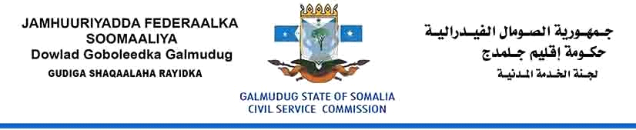

Vacancy Announcement
Director General
Ministry of the Disabled & Humanitarian Affairs
Grade: 8
Reporting to: Minister of the Disabled & Humanitarian Affairs
Salary: $1200
Location: Adaado-Somalia
Date of issued: 30 October, 2017
Closing date: 20 November, 2017

The Civil Service Commission is established to oversee the proper functioning of the Civil Service of the Galmudug State and to ensure that the Civil Service is efficient and effective in serving the community, affordable within state budget resources, and based on merit and equality of opportunity.

The Civil Service Commission is currently recruiting to fill the position of Director General to direct and coordinate the activities of the Ministry and set policy. This is a great opportunity for the right person to progress their career with the Civil Service and provide leadership in establishing this important Ministry for the benefit of the people of Galmudug State of Somalia (GSS). Ensuring a high standard of humanitarian care for the people of GSS and for the provision of support to the disabled and professional workers.

Purpose

The Director General is required to build a culture of professionalism, respect and integrity to ensure a positive working environment, acknowledging the responsibilities of Ministers and supporting managers to make evidence-based decisions. The Director General is responsible for ensuring that management decisions are free from nepotism, patronage and that are seen to be based on merit. He / she is expected to act truthfully, fairly and in the public interest in addition to creating and maintaining stakeholder confidence through leadership which fosters and promotes ethical, decision making is a key element of this position.

Duties and Responsibilities

The Director General (of the Disabled & Humanitarian Affairs) is most senior of Civil Servant the Ministry of the Disabled & Humanitarian Affairs, with portfolio oversight, including but not limited to the following responsibilities:

- Overall management of the Ministry, including Human Resources, Finance and Budgeting, Revenue Collection, Legislative Compliance and Public Health.
- Establishing and implementing government policies, strategies and programs related to administration, good governance, and its implementation.
- Keeping the Minister and Deputy Minister informed of policy implementation and advising the Minister and Deputy Minister on all questions of policy which are within the scope of the Ministry’s responsibility.
- Managing the performance of Ministry staff, in accordance with the Civil Service Act and Regulations, and ensuring the effective and efficient operation of the Ministry.
- Monitoring and executing the Ministry budget and that of the institutions under supervision of the Minister/Deputy Minister.
- Deliver high quality, innovative, value for money policies and services.
- Create strong partnerships and good collaboration across all sectors to optimise departmental performance.
- Develop a workforce and leadership practices that build a constructive culture with a focus on performance, capability building and personal accountability and nurturing of leadership potential.
- To produce guidelines, manage and assist humanitarian activities and affected communities to coordinate, plan, implement, monitor and evaluate essential actions that foster the full and effective participation and inclusion of persons with disabilities across all phases of humanitarian action
- To promote and raise awareness by building collaborative networks, working with stakeholders and delivering positive messages and action programmes/projects across the GSS that impact on disability and humanitarian areas.
- To ensure fair and equitable access to services, including education, employment and health to those affected by humanitarian and disability issues.
- Carry out any other tasks or assignments within this technical area as requested by the Minister.

Qualifications and Experience

- A degree in Public Health/Disability Studies/ Humanitarian, developmental studies, Social Science, International Studies are primarily considered, or relevant academic field. Having Master Degree in above fields is desirable.
- Have at least five (5) years relevant professional experience, two (2) years of which should have been in a leadership position or at a top management level in the Public Service or Private Sector.
- Strong leadership skills with experience of leading, managing and motivating a diverse team.
- Proven experience in health management and in developing strategic and business planning at a high level.
- Demonstrable experience of effective internal and external communication skills and political sensitivity

Knowledge

- A full understanding of the Disabled & Humanitarian Affairs system and processes in GSS.
- Strong understanding of government financial management and measures of performance.
- Sound knowledge of international standards of best practice.

Competences

- Possesses high level political, analytical, policy and management skills.
- The ability to provide leadership, direction and motivation to the Ministry of the Disabled & Humanitarian Affairs
- Excellent interpersonal and facilitation skills, including the ability to effectively work with and support the members of a team and work collegiately in partnership with a wide range of stakeholders.
- High standards of ethical behaviour and integrity.
- Ability to identify, analyse and solve complex issues.
- Excellent written and verbal communication skills in both English and Somali.
HOW TO APPLY:
Please download Application Form:
Interested candidates who meet the criteria are encouraged to fill the form and send to recruitment.cscgmstate.so@gmail.com, and please make sure to copy or Cc, the following email: csc.galmudug@gmail.com. CVs and Application Letter will not be considered, kindly indicate the position title and Ministry on the subject line when you applying. Female Candidates are strongly encouraged.

The selection process will begin as soon as possible after the closing date. Selected candidates will be invited to written Exam and an interview.

